SW Engineering CSC648/848 Fall 2023

Section 02

Team 02

Milestone 1

Lukas – lheber@sfsu.edu – Team Lead, Github Master
Marshall – back end lead
Danial – front end lead
Ely, Mark, Sanjith

Date: 10/21/2023

Date submitted: 9/19/2023
Date revised: 10/21/2023

Content
1. Executive summary 3
2. Personas and main Use Cases 4
3. List of main data items and entities 5
4. Initial list of functional requirements 6
5. List of non-functional requirements 7
6. Competitive analysis 9
7. High-level system architecture and technologies used 10
8. Team and roles 10
9. Checklist 10

1. Executive summary
In the ever-changing landscape of California, ensuring the safety and well-being of its residents is a top priority. California SafetyNet is dedicated to developing a cutting-edge web-based service that will revolutionize public safety and emergency management. This platform will empower the California State government, its county departments, and its citizens to effectively identify and respond to various safety and security emergencies, including COVID-19 outbreaks, extreme weather conditions, wildfires, and security threats.
California is a state known for its diverse geography and climate, but it is also prone to a wide range of natural disasters and health crises. Recent history has demonstrated the urgency of having a wide-scale comprehensive system in place to address these challenges. California SafetyNet is motivated by the imperative to enhance public safety and provide timely, accurate information to protect the lives and well-being of Californians. In a rapidly evolving world, the ability to access real-time data and receive relevant alerts can mean the difference between safety and disaster.
Our project offers a comprehensive suite of functions and services designed to meet the needs of both government agencies and citizens: County departments, including Health, Security, Weather, and Fire, will have the capability to input and update crucial metrics such as COVID-19 infection rates, wildfire data, extreme weather conditions, and security concerns. This streamlined data collection process ensures that accurate information is readily available. Residents will have easy access to vital information specific to their respective counties. This information includes infection rates, weather forecasts, wildfire status, and security alerts. Whether someone resides in the city of Los Angeles or the rural areas of Northern California, they will receive information relevant to their location. Citizens can register to receive timely alerts and notifications directly to their preferred devices. These alerts may include shelter-in-place notices, evacuation orders, and advisories to avoid specific areas due to security or weather-related issues. Our user-friendly interface allows individuals to tailor their preferences to receive the information that matters most to them. By aggregating critical data from various county departments into one easily accessible platform, the project offers a holistic view of safety conditions in real-time. This unified approach enables better-informed decision-making, facilitating a quicker and more coordinated response to emergencies. The platform's intuitive design ensures that it is accessible to individuals with varying levels of technical expertise. In a state as diverse as California, inclusivity is key. California SafetyNet's user-friendly interface ensures that vital safety information is accessible to everyone, regardless of their technological proficiency.
Our team of professionals, including experts in web development, data management, emergency response, and public safety, is united by a shared vision: to make California SafetyNet a reality. We bring a depth of knowledge and experience to the table, coupled with a deep understanding of the unique challenges that California faces in terms of public safety. In conclusion, the California SafetyNet project represents a pivotal advancement in the realm of public safety and emergency management. Beyond being a technological innovation, it serves as a lifeline for the residents of California. By centralizing critical information, streamlining communication, and providing real-time alerts, we are on a mission to create a safer California.

2. Personas and main Use Cases
P1. California general public:
Anyone in California, resident or non-resident.
Directly affected by the interested metrics.
General knowledge of present conditions and situations.
Can quickly report situations at large quantities.
Are very curious about what’s going on nearby.
P2. County Directors of Health, Security, Weather and Fire Departments:
People of expertise in their field of study and profession.
Not necessarily directly affected by the interest metrics.
Highly knowledgeable of present situation regarding their field.
Highly concerned about public health and safety.
Can make decisions that can lead to higher survival.
Proficient in analyzing data.
P3. Site Admin:
Must be highly knowledgeable.
Proficient knowledge about State Guidelines.
Very responsible.
Maintain integrity and accuracy of information on the application.
Ethical and highly concerned for the public.
Use cases
P1 use cases:
People are witnessing a shooting and they post reports to the application.
They see a brush fire building up momentum and they post a warning.
People are planning to go on a trip from Northern California to Southern California,
They check the app to see if there’s anything to look out for. They would be interested in Covid cases or violent areas to avoid, etc.
P2 use cases:
They notice a lot of reports of violence in a particular area and they send warnings to avoid the area.
When there is extreme weather conditions, they will suggest alternative routes due to flooding or road blocks.

P3 use cases:
They see the warnings and alerts from P2 and they will make those information live in accordance to the State Guidelines.

3. List of main data items and entities
- User Entity:
What: Represents an authenticated user in the system.
Usage: Used to authenticate and set roles (Admin or User).
- County Entity:
What: Represents a county in the system.
Usage: Used to categorize metrics/stats and alerts by location.
- Department Entity:
What: Represents one of the following departments - Health, weather, wildfire & Security.
Usage: Maps Department to county.
- Metric/Stats Entity:
What: Holds the stats that departments report.
Usage: Used to inform the Users and trigger alerts.
- Alert Entity:
What: Contains the warnings or notifications sent to users.
Usage: Used to inform Users about urgent situations based on metrics.

Types of Users and Their Privileges
- P3 Site Admin:
  - Privileges: Responsible for overseeing the overall functionality of the system. Can approve metrics, trigger alerts, and manage users.
  - Usage: Maintains the system.

- P2 County Directors:
  - Privileges: Experts in their domain will be able to trigger alerts (no user management)
  - Usage: Sets metrics, trigger alerts in their domain.

- P1 general public:
  - Privileges: Allowed to view metrics and receive alerts. Can’t change metrics or trigger alerts.
  - Usage: Gets the metrics and alerts relevant to their counties.

Main Terms and Their Definitions
- Metric/Stats:
Meaning: Stats of specific conditions or events.
Usage: Metrics are entered by Admins and are used to inform the users as well as to trigger alerts.
- Alert:
Meaning: A warning or notification generated based on certain conditions in the metrics.
Usage: Alerts are triggered by Administrators and sent to public users to inform them about urgent or critical situations.
- County:
Meaning: A geographical and administrative location within California.
Usage: Used to add/find metrics/stats and alerts by location.
- Department:
Meaning: An entity responsible for a particular area such as health, security, or weather.
Usage: Used to specify department which is responsible for each metric

4. Initial list of functional requirements
- Adherence to Regulations: Software shall have a resource link page to county regulations for data security and privacy.
- Administration Control Panel: Administrators shall be able to access an interface where they may control users, content, and notifications.
- Alert Initiation: Administrators shall be able to set off notifications depending on predetermined parameters, such as COVID-19 infection rates, wildfire evacuation levels, and security issues.
- Community Forum: Shall give people a place to contribute information and take part in community conversations.
- Crowdsourced Data Submission: Users shall be able to input crowdsourced data, such as information about roadblocks, detours, and security issues.
- Customizable Alerts: Users shall be able to change alert choices, including the alert categories and transmission methods.
- Data Integration in Real Time: Shall be able to obtain current information on COVID-19, weather patterns, and wildfires by integrating with governmental organizations.
- Embedded messaging: Users shall be able to communicate during emergencies by sending and receiving messages within the platform via in-site messaging.
- Emergency Resource Directory: Shall offer a thorough listing of all available emergency services, including hospitals, fire stations, police stations, and shelters for evacuees.
- Entry for County Metrics: COVID-19, weather, wildfire, and security metrics shall be entered and updated by county departments (Health, Security, Weather, and Fire).
- Feedback Mechanism: Shall implement a feedback system so that users may report problems and make suggestions for changes.
- Help Center: Shall offer a thorough help center with FAQs and instruction manuals.
- Mapping Interface: Shall interact with interactive maps to view emergency occurrences, metrics, and county-specific data.
- Marketing Integration: Shall develop marketing plans and collaborate with regional government organizations to increase the uptake of the platform.
- Multilingual Support: Shall support several languages to serve California's multicultural population.
- Multi-Platform Support: Shall improve usability and accessibility by expanding the service to mobile apps and making sure consumers can access it on a variety of hardware and software.
- Privacy Settings: Users shall be able to control their privacy preferences and decide what information they want to make available with others.
- User Login: Users shall be able to register.
- User Access: Users shall be able to access the system by logging in.
- User Registration: Users shall be able to register for accounts only by providing a working email address as confirmation in order to access the platform's features.
With an emphasis on what the system shall be able to accomplish to meet user needs, these functional requirements offer a high-level overview of the primary characteristics and functions that comprises our web-based emergency service. They will act as the basis for additional thorough design and development activities.

5. List of non-functional requirements
- Application shall be developed, tested and deployed using tools and servers approved by Class CTO and as agreed in M0 (some may be provided in the class, some may be chosen by the student team but all tools and servers have to be approved by class CTO).
- Application shall be optimized for standard desktop/laptop browsers e.g., must render correctly on the two latest versions of two major browsers
- Selected application functions must render well on mobile devices (this is a plus)
- Data shall be stored in the team’s chosen database technology on the team’s deployment server.
- Privacy of users shall be protected, and all privacy policies will be appropriately communicated to the users.
- The language used shall be English.
- Application shall be very easy to use and intuitive.
- Google maps and analytics shall be added
- No e-mail clients shall be allowed. You shall use webmail.
- Pay functionality, if any (e.g. paying for goods and services) shall not be implemented nor simulated in UI.
- Site security: basic best practices shall be applied (as covered in the class)
- Modern SE processes and practices shall be used as specified in the class, including collaborative and continuous SW development
- The website shall prominently display the following exact text on all pages "SFSU Software Engineering Project CSC 648-848, Fall 2023. For Demonstration Only” at the top of the WWW page. (Important so not to confuse this with a real application).

6. Competitive analysis
Features: Some of the feature that our web application has
County metric dashboard
Public Alert notification
County specific Information
Media Rich user experience
Unique Feature: Community Collaboration hub

Main Competitors:
FEMA's IPAWS (FEDERAL EMERGENCY MANAGEMENT AGENCY)
RED CROSS EMERGENCY APP
Nextdoor

Feature | NEXTDOOR | FEMA's IPAWS | RED CROSS EMERGENCY APP | Our Service
County Metric input | NO | NO | NO | YES
Public Alert Notification | Limited | YES | YES | YES
Community Collaboration Hub | YES | NO | NO | YES
Administrative Control Panel | Limited | YES | Limited | YES
Responsive Design for all devices | YES | YES | YES | YES

Our team’s planned web-based emergency and disaster management service exhibits several significant competitive advantages. It uniquely enables county departments to input and manage critical metrics, ensuring data accuracy and setting it apart from competitors. Furthermore, our service offers comprehensive public alerts while incorporating additional functionalities, providing a holistic approach to emergency management. The standout feature is the Community Collaboration Hub, promoting active community engagement during crises, a valuable asset absent in other solutions. Localized administrator control with granular management options enhances flexibility and customization. Finally, service ensures cross-device accessibility with responsive design and offers a media-rich user experience, including maps and interactivity, improving user engagement and information comprehension. These unique features position our service as a robust and user-centric solution in the field of emergency and disaster management.

7. High-level system architecture and technologies used
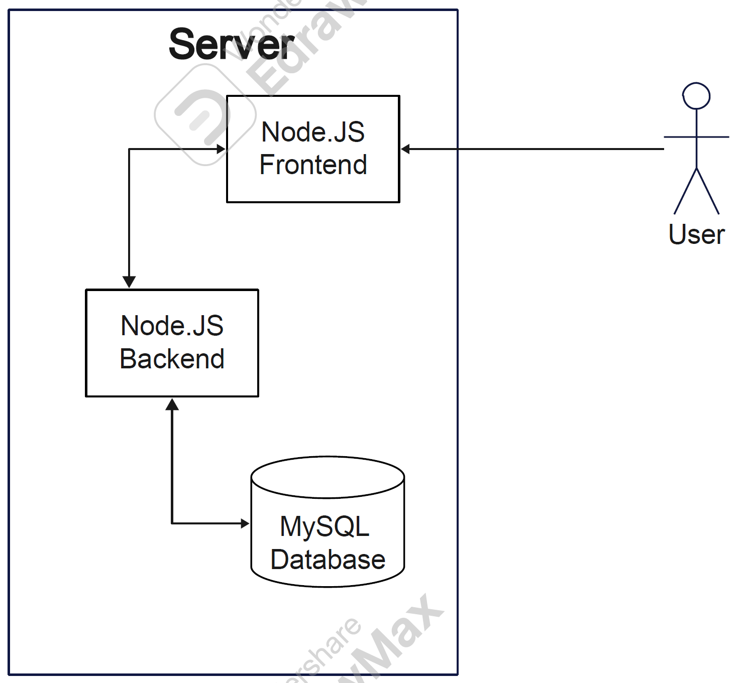
Sever Host: AWS t2.micro (1 vCPU, 1 GiB Memory)
Operating System: Ubuntu Server 22.04
Database: MySQL v8.1
Web Server: Apache HTTP Server v2.4.57
Server-Side Language: JavaScript
Additional Technologies:
Web Framework: Node.js 18.17.1
IDE: Webstorm InteliJ
SSL Cert: Lets Encrypt (Cert Bot)
Styling: Sass

8. Team and roles
Team Lead, Github Master, Document Editor: Lukas
Back End Lead: Marshall
Back End: Ely
Front End Lead: Mark
Front End: Danial
Database: Sanjith

9. Checklist
- Team found a time slot to meet outside of the class: DONE
- Github master chosen: DONE
- Team decided and agreed together on using the listed SW tools and deployment server: DONE
- Team ready and able to use the chosen back and front end frameworks and those who need to learn are working on learning and practicing: DONE
- Team lead ensured that all team members read the final M1 and agree/understand it before submission: DONE
- Github organized as discussed in class (e.g. master branch, development branch, folder for milestone documents etc.): DONE

